

FPT-APTECH COMPUTER EDUCATION

|  |
| --- |
| Project Bank247 Document |

Tien Phong Bank

**Group 4**

**Group Member :**

1. NGUYEN TUAN MINH - D00562

2. DO VAN QUYEN - D00557

3. NGUYEN HONG HANH - D00567

4. NGUYEN TUAN ANH - D00566

**Instructor :** TRAN VAN DIEP

**Batch T1707A**

**Semester 2**

**FPT APTECH**

**I.Introduction**

Bank of the TPB standard development multiple new ATM tree for the customer. You do you development a software help the following actions:

+ Employer Bank: Create New Account Manager, Customer transaction

+ Customer: Check balance, Print copy declaration, Deposit, Withdrawal, Trasfers v.v..

**II.Our solution**

* We developed the 247 bank application on two web and mobile (ios) platforms .

- Web : we design website such as home page, sign page, login page, user page, trasaction page, admin page .

- Moblie (ios) : We have developed applications such as deposit, withdrawal, money transfer, checking balance, we also help users find TPBank on the map, look up transaction history, send notifications to users .

**III.Our web**

**1.Home Page**

- The homepage has a suitable logo, login and register.

- Menu bar with Homepage link, Introduction, Service, Community Activities, About and Contact.

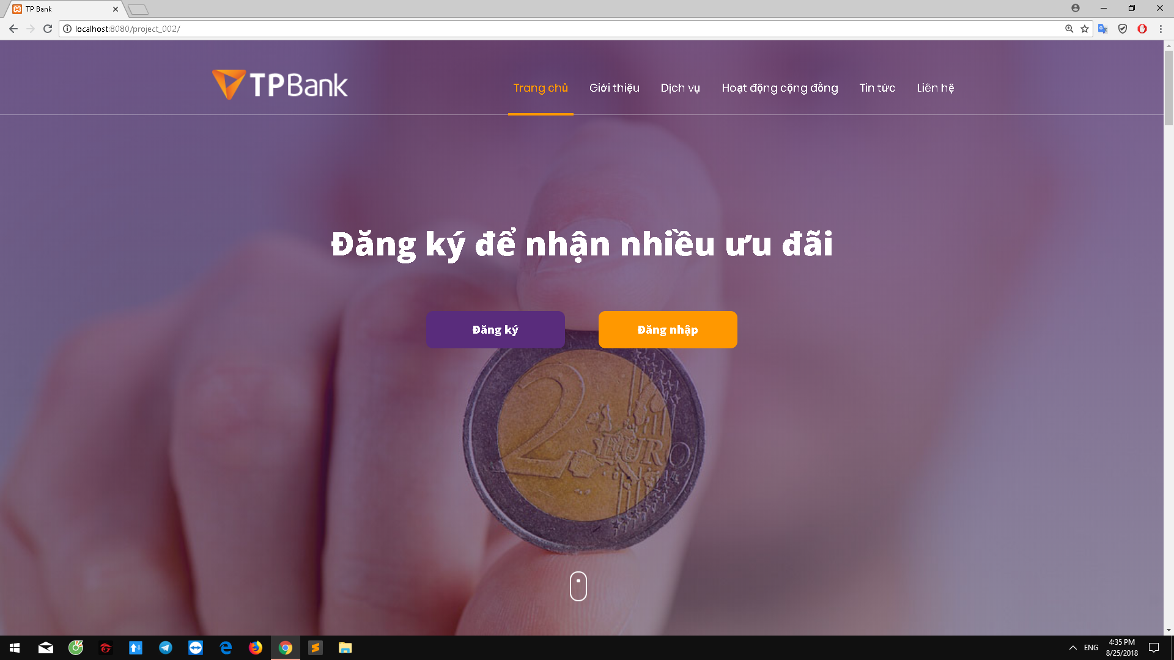

**\*Wellcome content :**

General information about the bank with the most basic information about the bank such as the history of banking formation, the motto of the bank ...

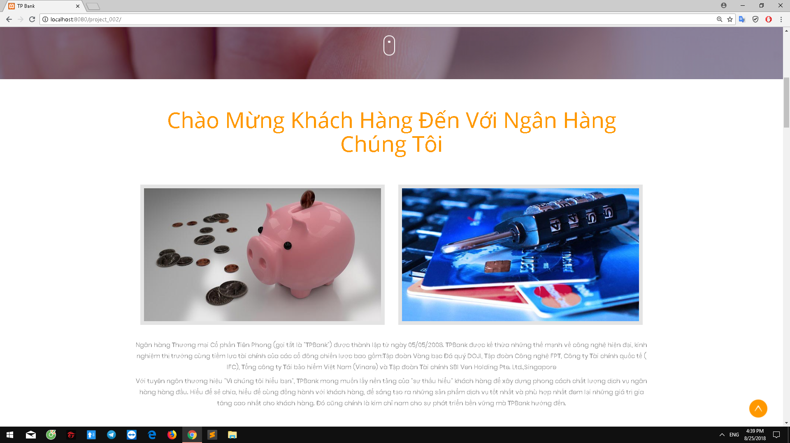

**\* Service content** :

Customers can learn about banking services along with information about promotions and loans at news bar .

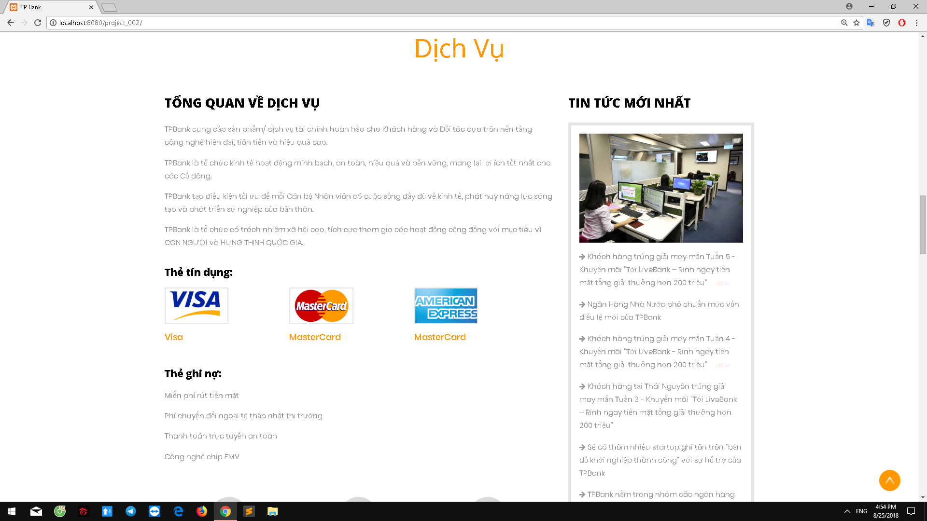

**\* Community Activities content :**

Everybody can monitor the community activities of all employees of the bank such as environmental sanitation, charity, fundraising ...

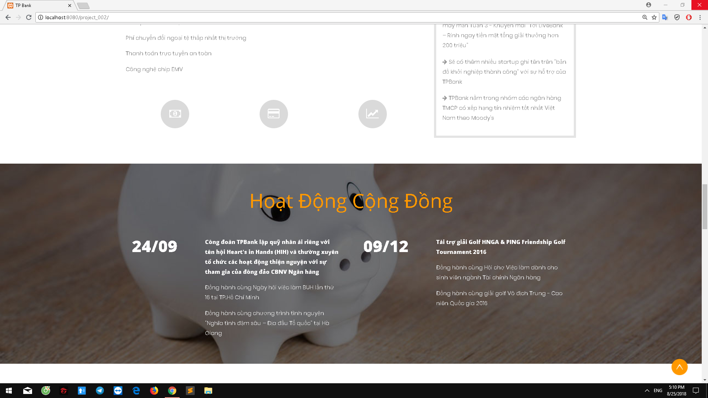

**\* Event content :**

People can follow the events organized by the bank as well as coordinate the organization .

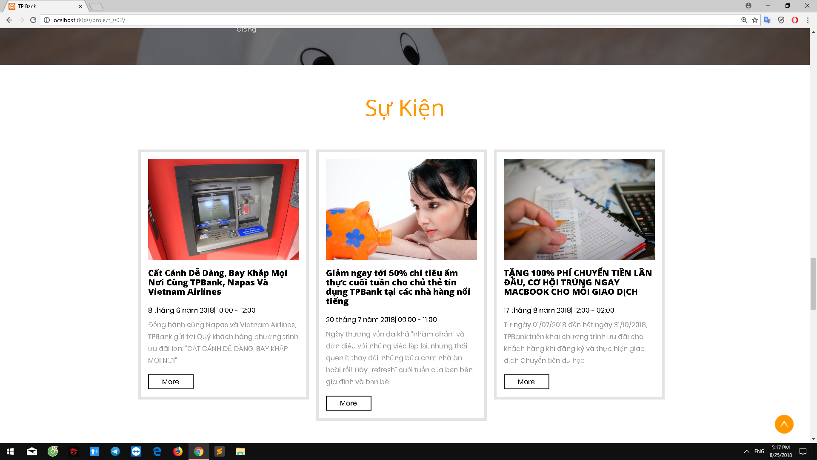

**\* Feedback from customer :**

Anyone can see the feedback of customers using banking services can evaluate the quality of service through it .

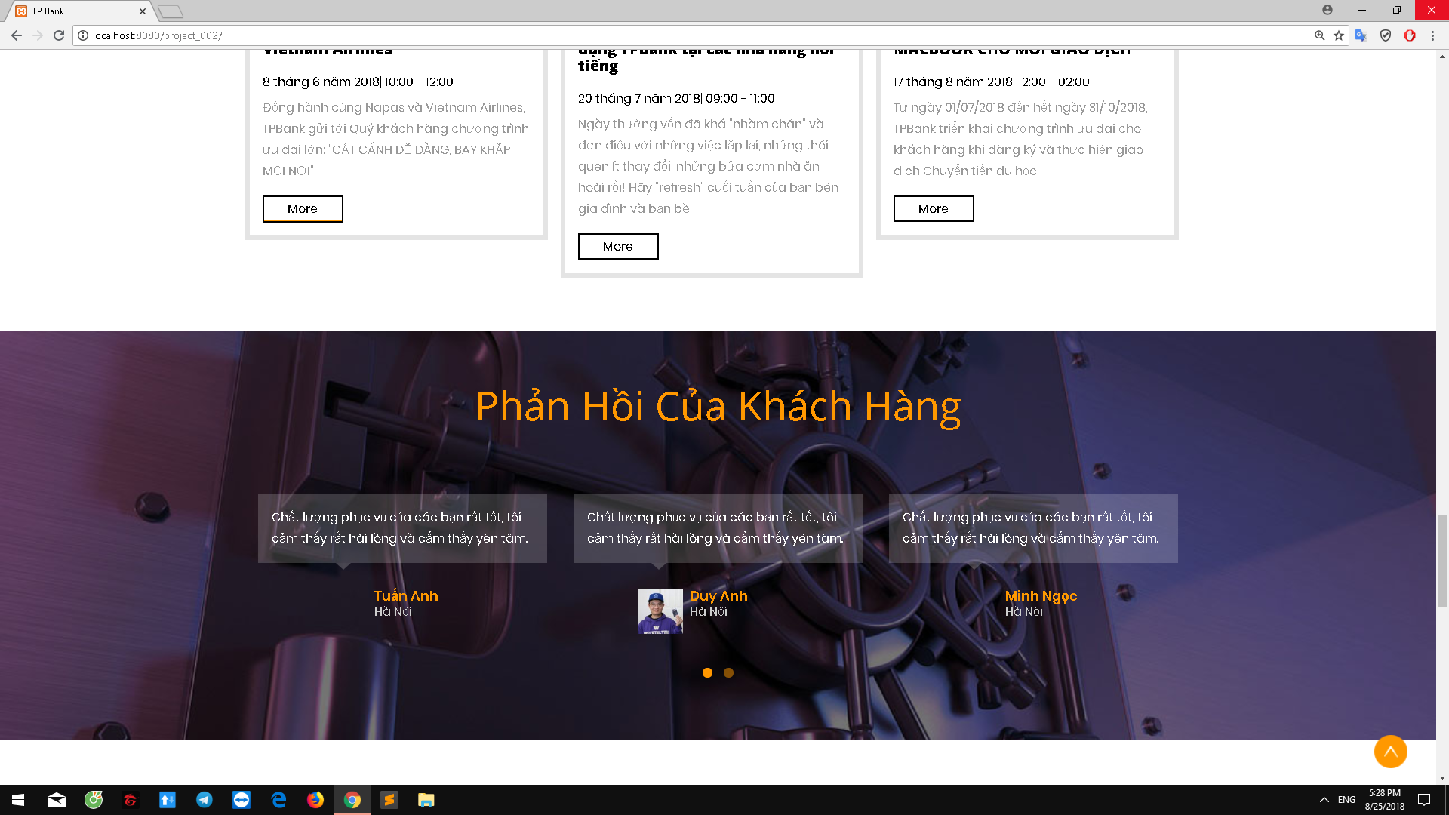

**\* Contact us :**

Customers can contact us by phone, email and address on the screen and also contact us through the feedback system or social network .

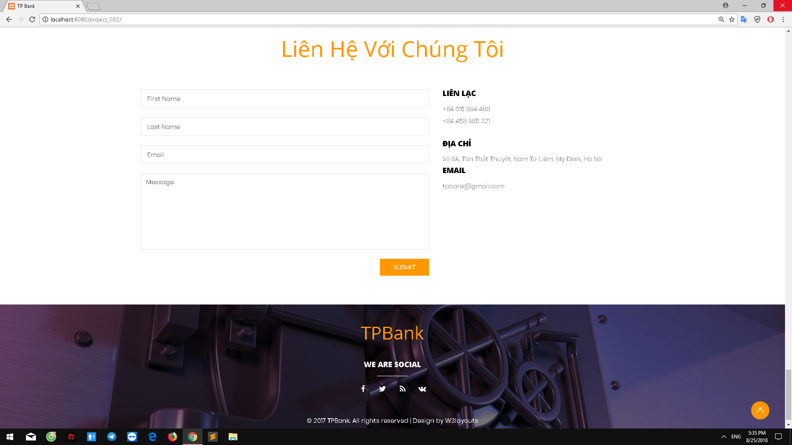

**2.Register page**

- On this page, there is a form of registration asking customers to enter information about username, login password, full name, email, phone number, birthday, ID card and save to database .

- The registration form is fully validated .

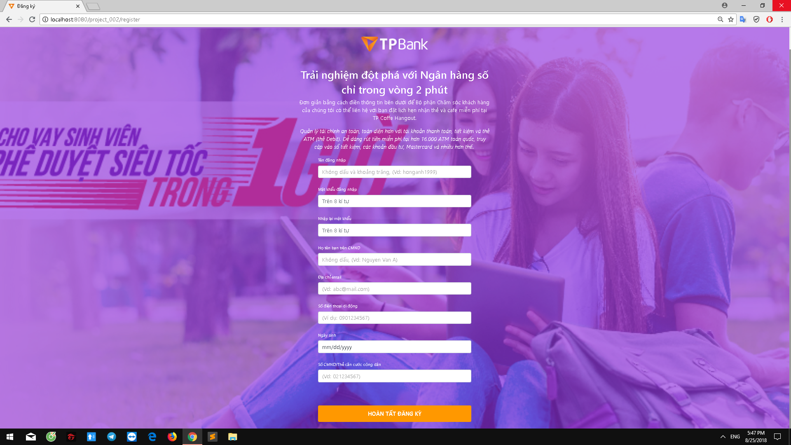

**3.Login page**

- This page has 1 form request to user login : username and password

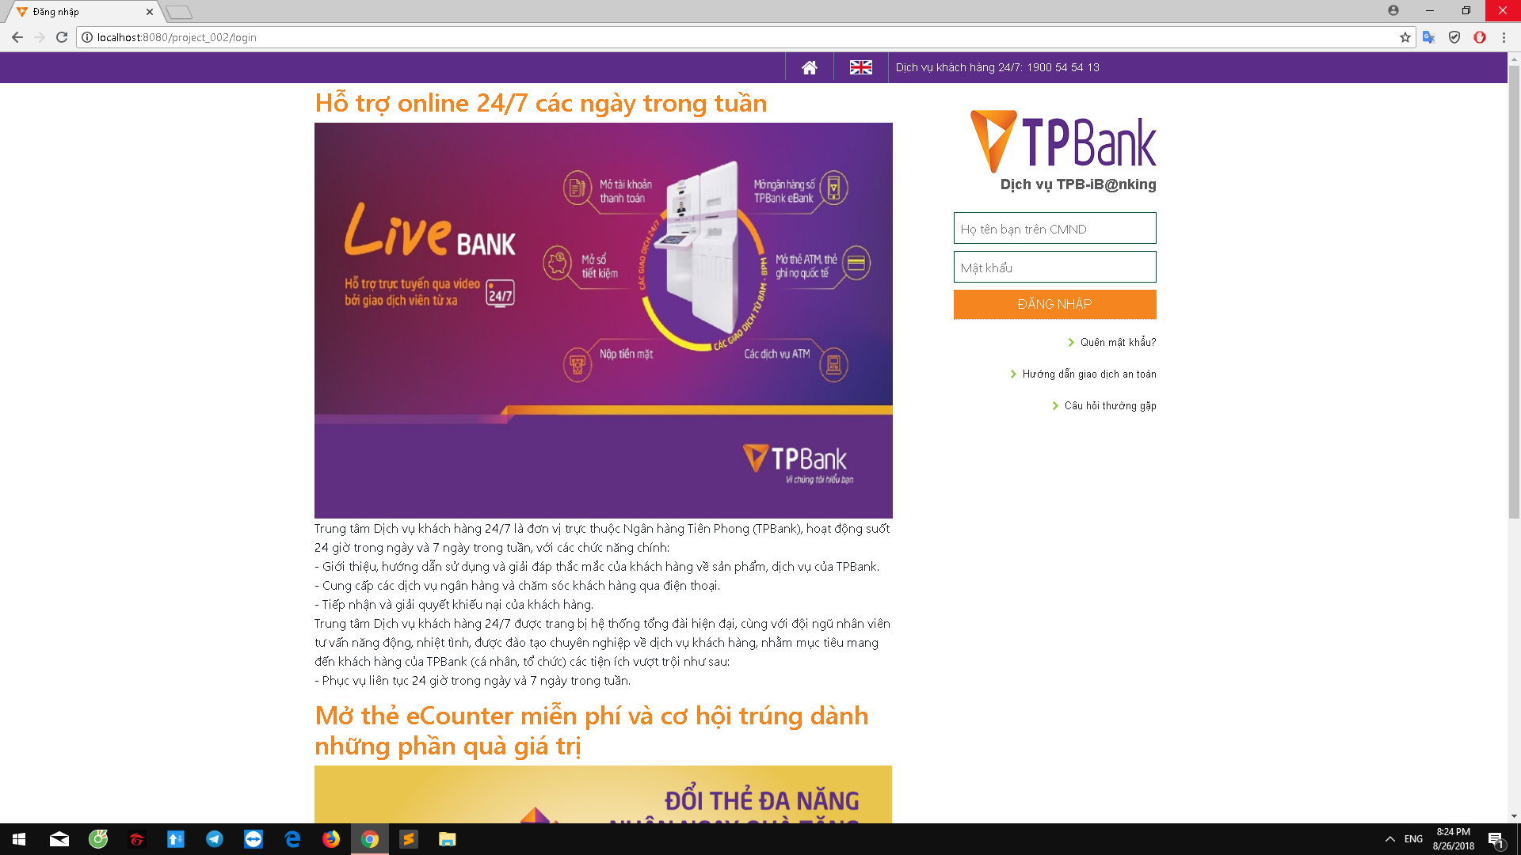

**4. Customers page**

- Once you log in you will be taken to the customer page .

- Here you can view account information, edit information, check balance, withdraw money, transfer money, view transaction history and print invoices.

**+ Account information :**

You can see: account holder name, login name, password, email, account number, balance, ID number, phone number, address, date of birth, gender and you can change them.

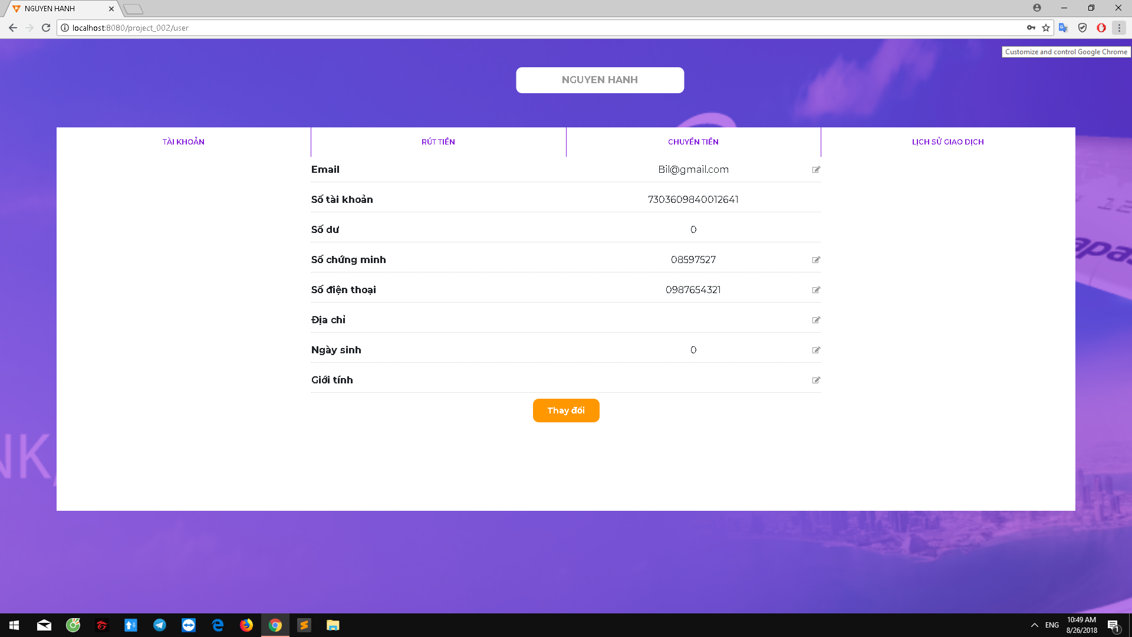

**+Withdrawal money:**

Here you can withdraw money at the current price or optional amount attached to the message

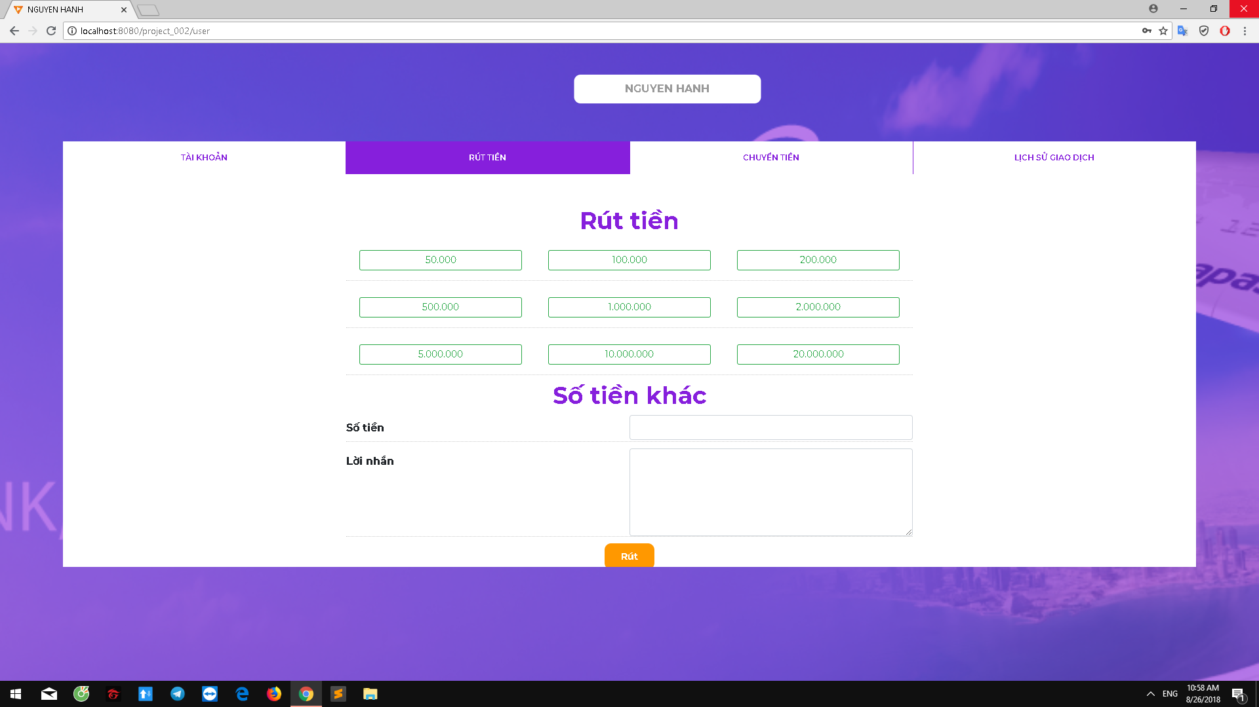

After you press the withdrawal will appear a message, here you can check the information as well as print invoices

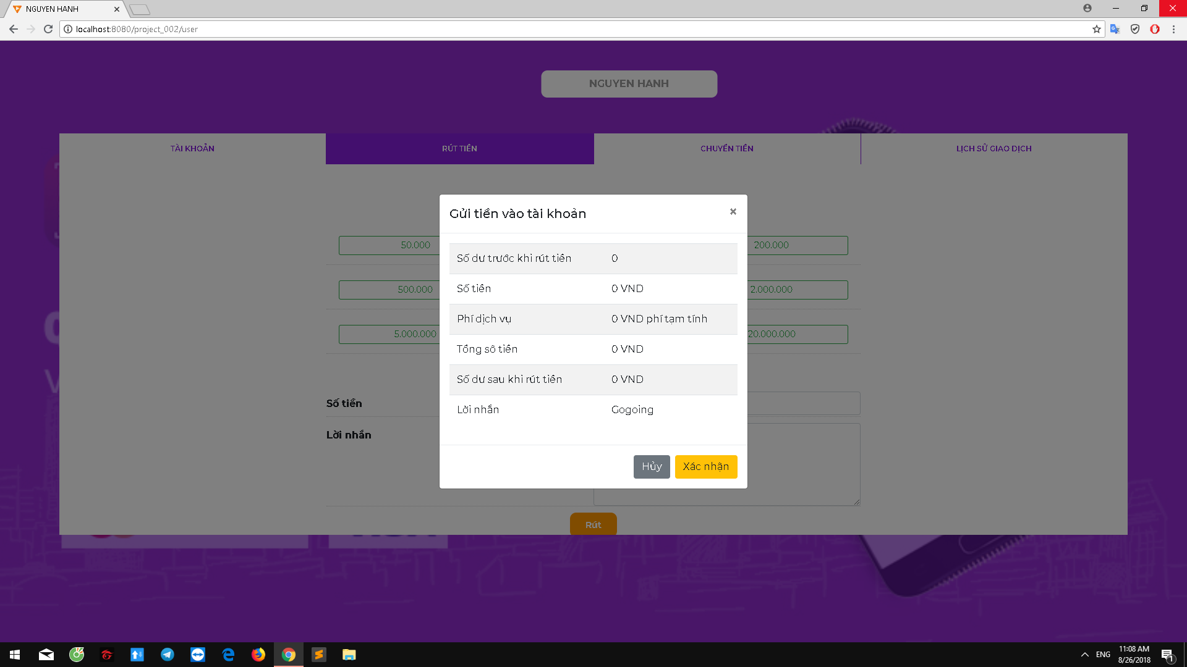

**+Transfer money :**

Here you enter the recipient's name, recipient's account number, amount and message .

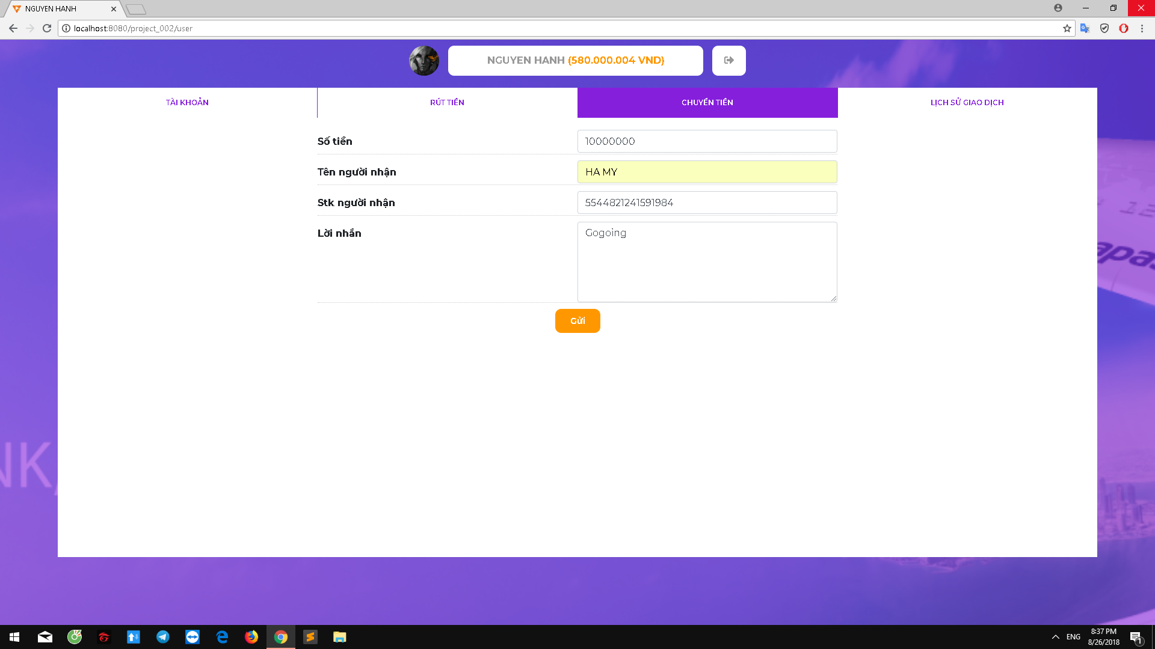

After you press the transfer will appear a message, here you can check the information as well as print invoices .

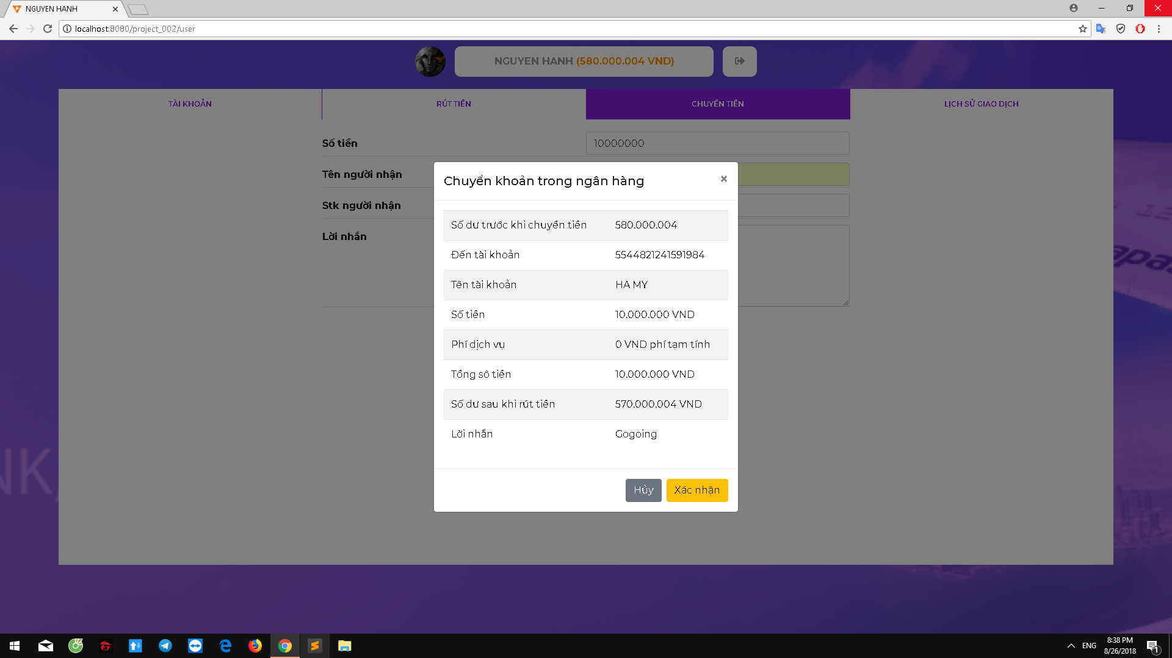

**+ Transaction history :**

You can view the history of trading day, yesterday, within 7 days before ...

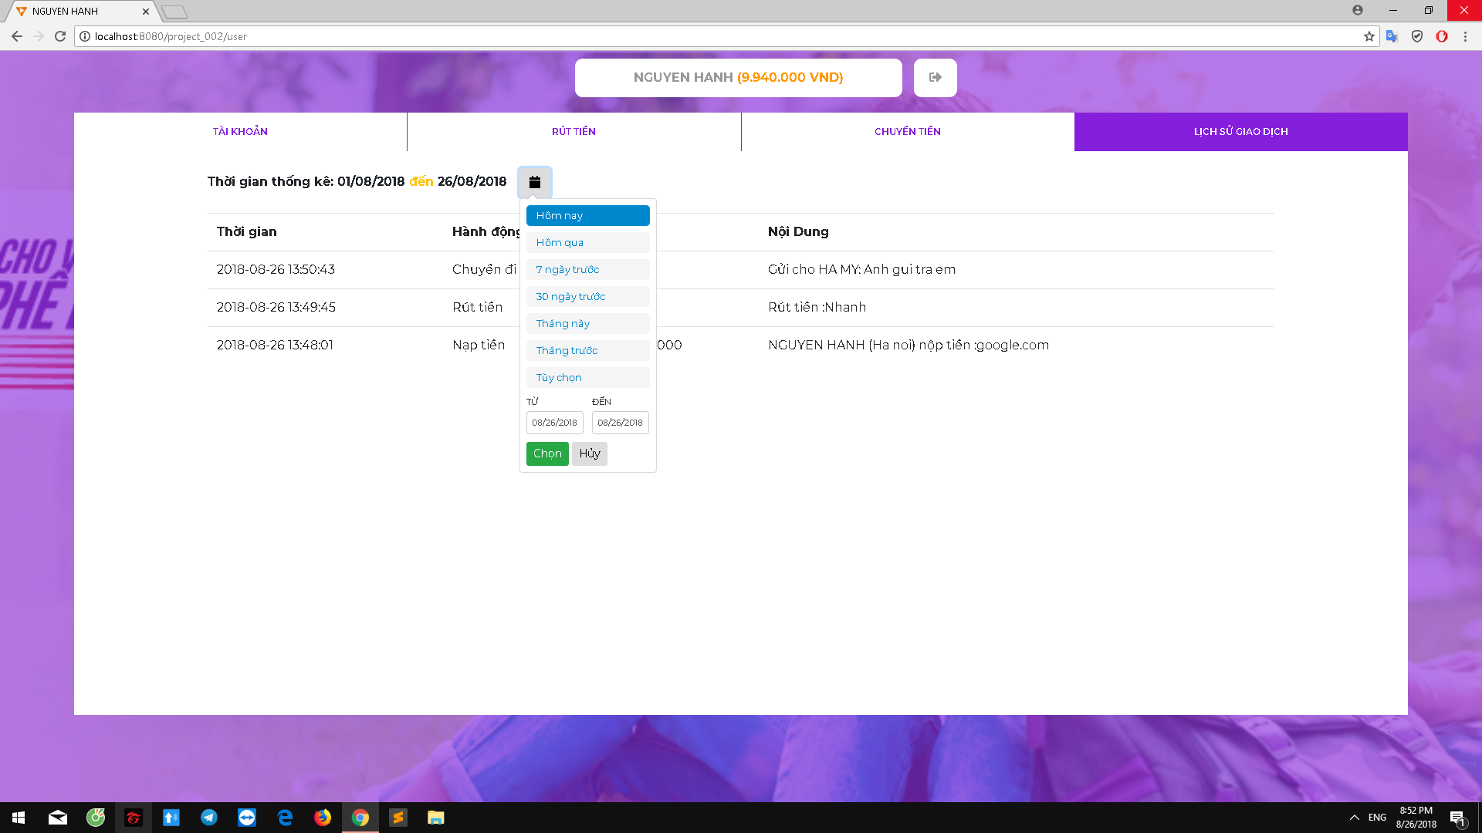

**5. Bank staff page**

Here the banker can manage customer accounts, manage transactions, add money to customers .

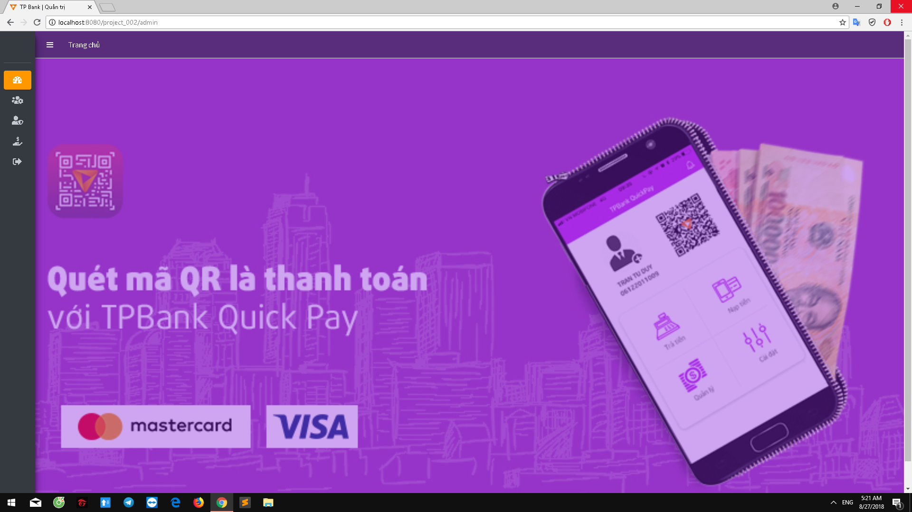

**\* Manage client accounts :**

Bank staff can view and edit personal information of customers except information about account number and balance, check transactions of customers, add customers .

**- List account :**

Bank staff will repair and check transaction history of each customer here .

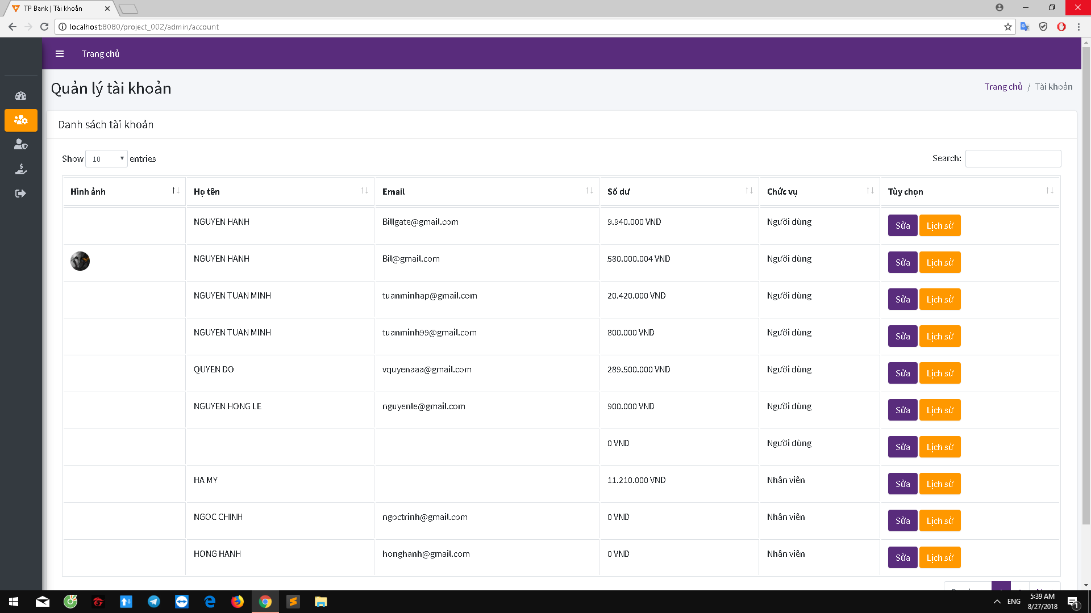

**- Add account :**

Bank staff active accounts for new clients here .

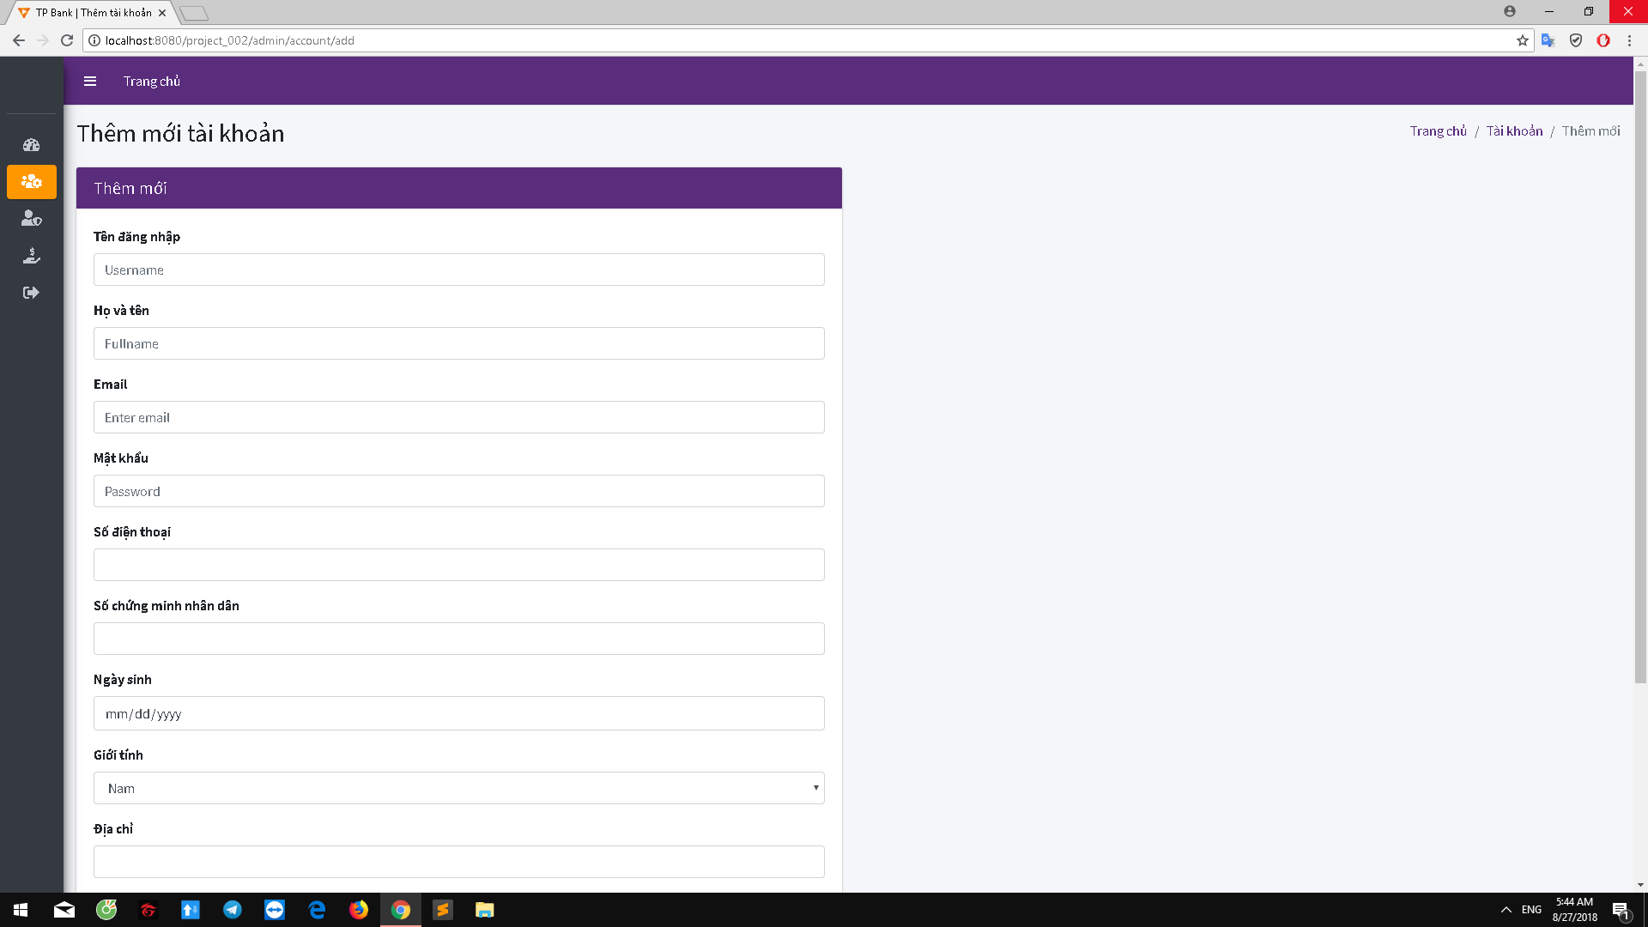

**\* Admin account management :**

Bank staff can edit their personal information and password here .

**- Edit infomation :**

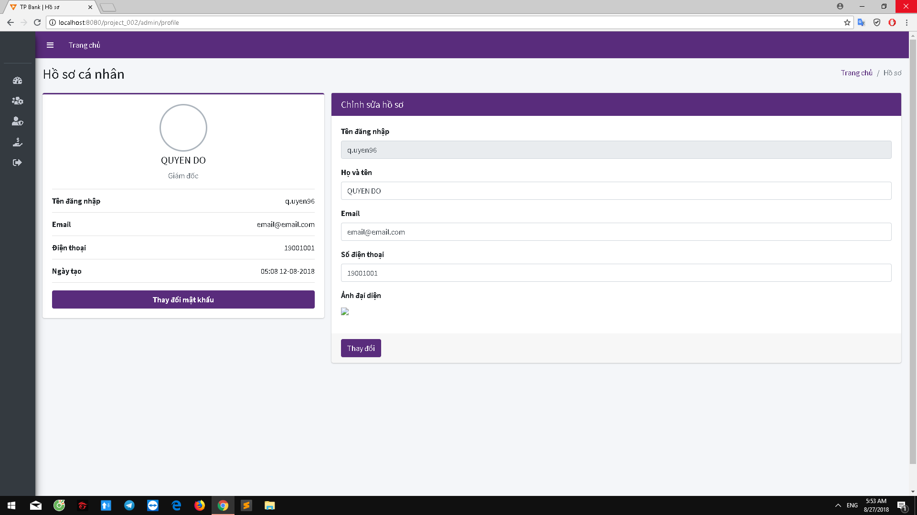

**- Edit password :**

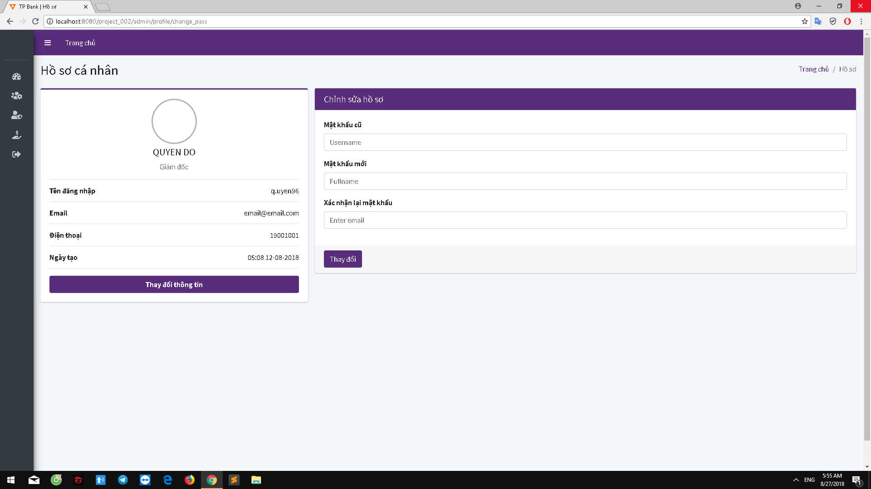

**\* Put money into account for customers :**

Prior to filling the employee must enter the account number and name on the customer ID card, the amount of money to enter

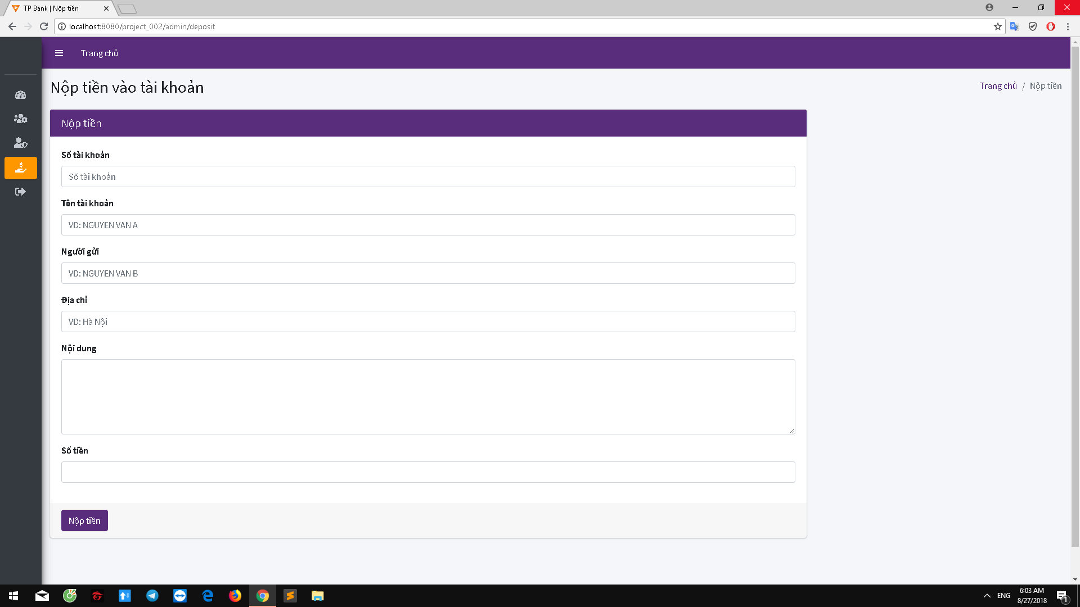

III.Our mobile application